**CMPE 360 HOMEWORK3**

**PART1**

**A)**

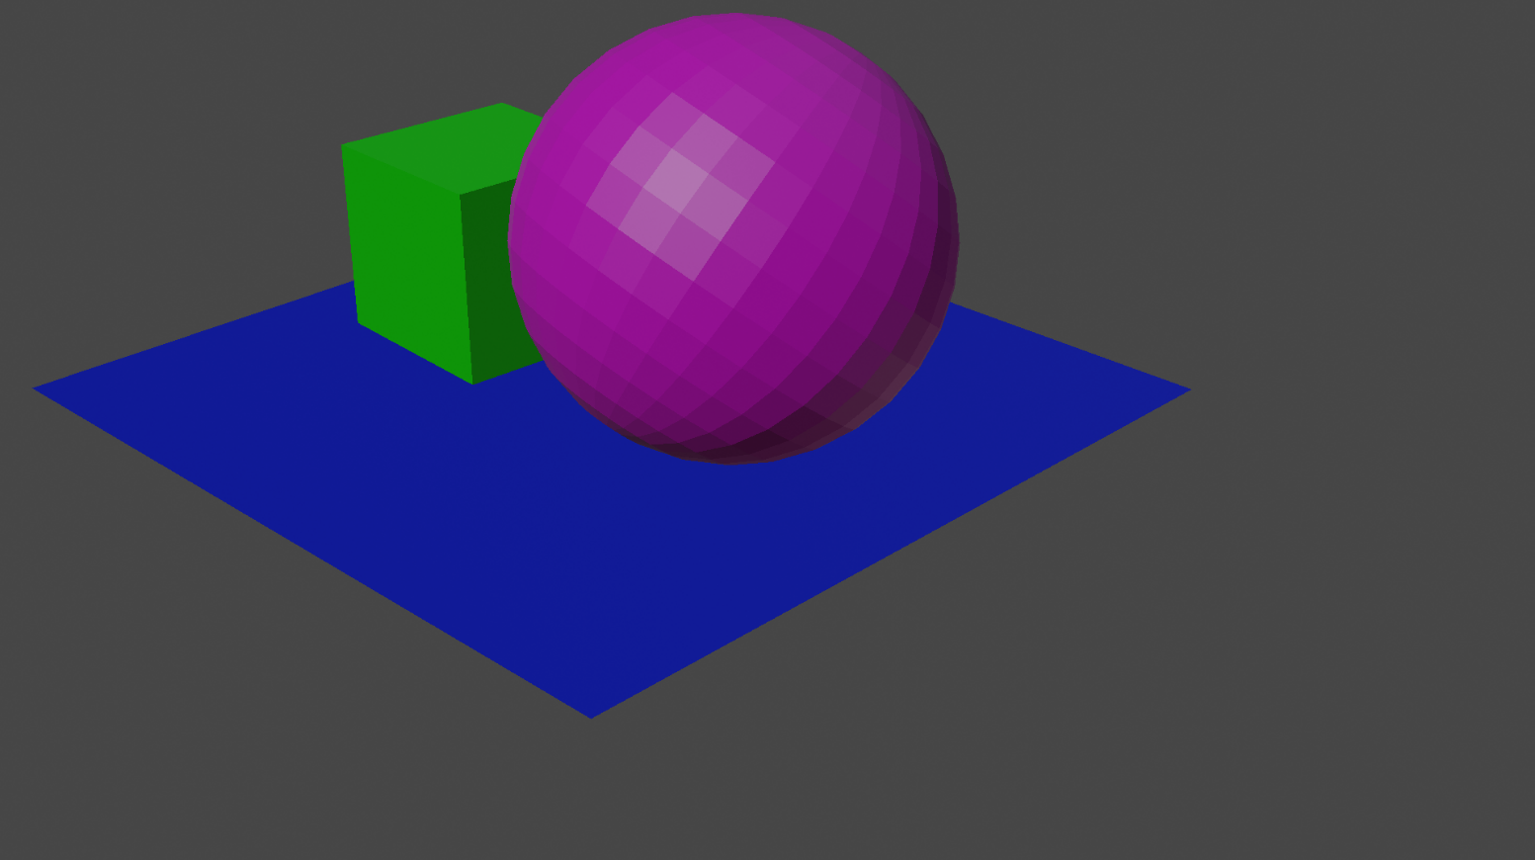

Figure 1.1 Rendered Image with 1920x1080.

**B)**

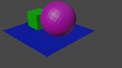

Figure 1.2 Rendered Image with 160x90.

**C)**

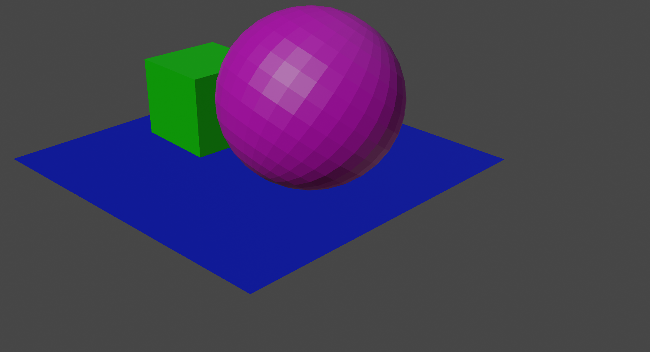

Figure 1.3 Rendered Image with 3840x2160.

1. **Compare the images that are 1920x1080, 160x90 and 3840x2160. Write the effect of changing the resolution.**

The difference is in the number of pixels. We can see the difference between 2160p and 1080p much more clearly when we zoom in on the images.

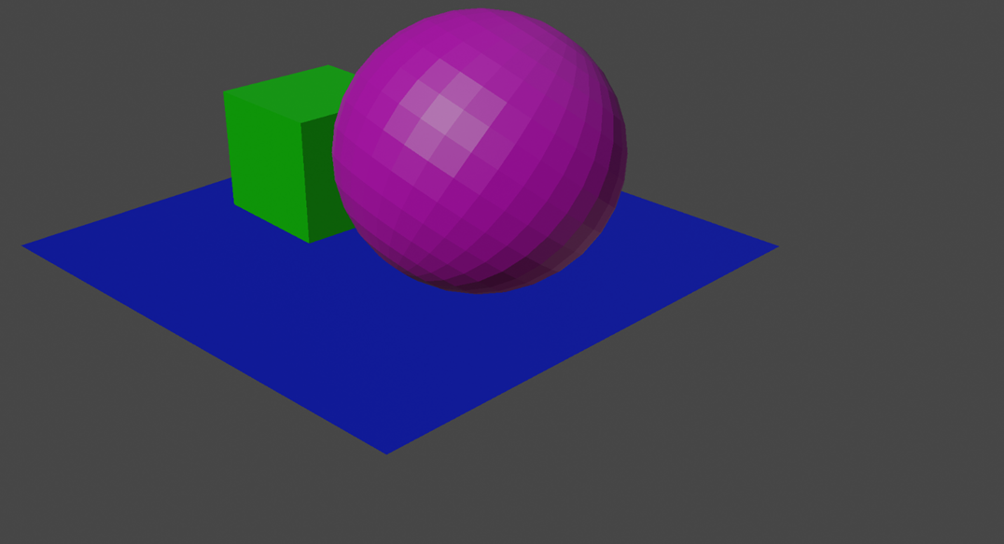 **E)**

Figure 1.4 Rendered Image with gamma 1.

**F)**

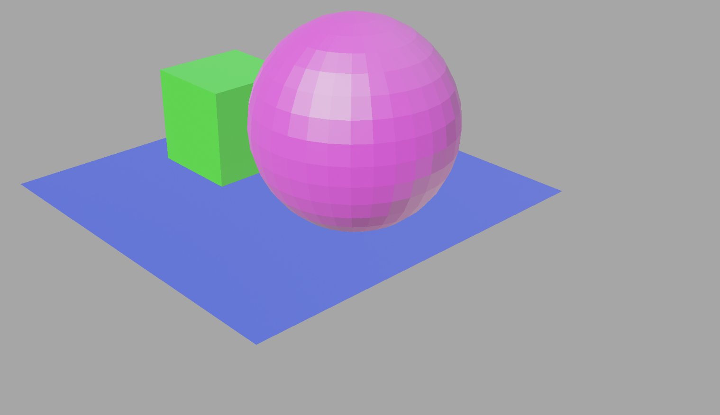

Figure 1.5 Rendered Image with gamma 3.

**G)**

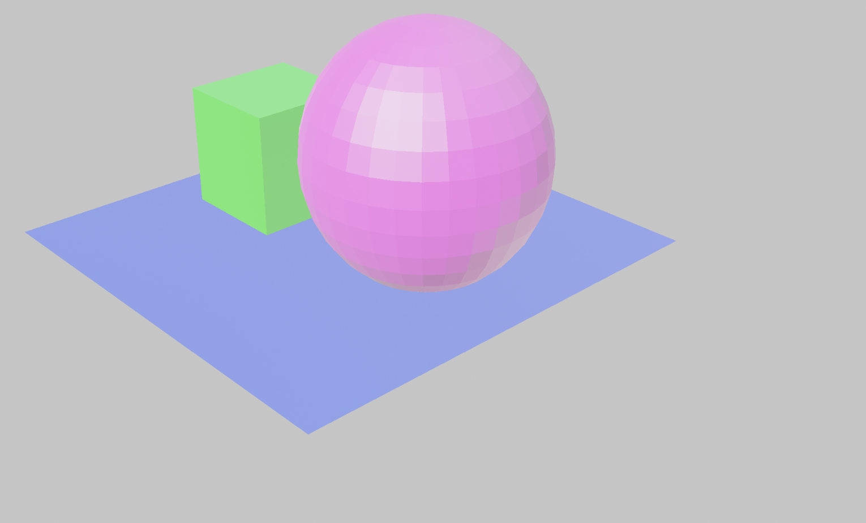

Figure 1.6 Rendered Image with gamma 5.

1. **Compare the images that have gamma value 1,3 and 5. Write the effect of changing the gamma value.**

Changing gamma values alters the brightness and contrast of images. In photographs, as gamma values increase from low to high, both brightness and contrast values increase.

1. **Answer this question and write your document, What's the advantage of using YUV color space?**

Effective data separation, enhanced compression, lower bandwidth requirements, superior color correction, compatibility with analog signals, fewer processing artifacts, and support for many color spaces in image and video applications are just a few benefits of the YUV color space.

**PART 2**

1. **Write down pxy**

For pxy:

Rotate along the global X-axis by +45°: R_x(45°)

Rotate along the global Y-axis by +45°: R_y(45°)

To find pxy, multiply these two matrices with the original vertex v:

pxy = R_y(45°) * R_x(45°) * v

Here is the result after multiplying these matrices:

pxy = R_y(45°) * R_x(45°) * v

= (R_y(45°) * (R_x(45°) * v))

1. **Write down pyx**

for pyx:

Rotate along the global Y-axis by +45°: R_y(45°)

Rotate along the global X-axis by +45°: R_x(45°)

To find pyx, multiply these two matrices with the original vertex v:

pyx = R_x(45°) * R_y(45°) * v

Here is the result after multiplying these matrices:

pyx = R_x(45°) * R_y(45°) * v

= (R_x(45°) * (R_y(45°) * v))

These calculations will give you the world location of the vertex v after the specified rotations.

1. **Explain how you get these results.**

To calculate the world location of the vertex v after the specified rotations using rotation matrices, you can follow these steps:

For pxy:

1. Rotate along the global X-axis by +45°: R_x(45°)

- The R_x(45°) matrix represents a rotation of 45 degrees counterclockwise about the global X-axis.

2. Rotate along the global Y-axis by +45°: R_y(45°)

- The R_y(45°) matrix represents a rotation of 45 degrees counterclockwise about the global Y-axis.

3. To find pxy, multiply these two matrices with the original vertex v:

- pxy = R_y(45°) * R_x(45°) * v

4. Perform the matrix multiplications in the order specified, which means you first apply the R_x(45°) transformation to v and then apply the R_y(45°) transformation to the result.

For pyx:

1. Rotate along the global Y-axis by +45°: R_y(45°)

- The R_y(45°) matrix represents a rotation of 45 degrees counterclockwise about the global Y-axis.

2. Rotate along the global X-axis by +45°: R_x(45°)

- The R_x(45°) matrix represents a rotation of 45 degrees counterclockwise about the global X-axis.

3. To find pyx, multiply these two matrices with the original vertex v:

- pyx = R_x(45°) * R_y(45°) * v

4. Perform the matrix multiplications in the order specified, which means you first apply the R_y(45°) transformation to v and then apply the R_x(45°) transformation to the result.

The result of these matrix multiplications gives you the final world location of the vertex v after the specified rotations. Matrix multiplication applies each transformation in sequence, and the order of multiplication is crucial, as it affects the final position of the vertex in the 3D space. These calculations represent the transformation of the vertex as it moves through the specified rotations in 3D space.

1. **Write down t1 cube world**

To find the global location of the cube after parenting and then applying transformations to the plane, we can follow these steps:

Following parenting, tcube local = [0, 0, 0] represents the cube's translation with respect to the plane.

By setting the plane's location to tplane world = [x, y, z], we are specifying the plane's global position.

Since the cube tracks the global position of the plane, its global location, t1 cube world, is equal to the sum of tcube local and tplane world:

t1 cube world = tcube local + tplane world

t1 cube world = [0, 0, 0] + [x, y, z]

t1 cube world = [x, y, z]

So, the global location of the cube after the first transformation is [x, y, z].

1. **Write down t2 cube world**

Next, we can adjust the global position of the cube by rotating the plane by -45° along its local X-axis. The cube follows the transformations of the plane; its local rotation stays at [0, 0, 0].

We must consider how the rotation will affect the cube's position to determine the cube's global location following the rotation, or t2 cube world. We must take into consideration how the cube's position has changed because of the plane's rotation, if its local position after the rotation stays [0, 0, 0].

The cube's global location will be at the same distance from the plane's origin but rotated by -45° around the X-axis due to its current angle of -45° with respect to the plane.

globe = [x, y, z] rotated by -45° around the X-axis is the t2 cube.

You would need to apply a rotation matrix representing a -45° rotation around the X-axis to [x, y, z] to get the cube's new global position. The values of x, y, and z as well as the rotation matrix in use would determine the precise coordinates of the t2 cube world.

1. **Explain how you get these results**

Gaining insight into Blender's transformation and object parenting techniques yields the desired outcomes. This is how we get these findings:

**1.Looking after the Cube and the Plane:**

At first, the plane and the cube are two different things.

Parenting the cube to the plane establishes a link between parent and child. It follows that the transformation of the cube will be relative to the plane. The cube experiences the same changes as the plane does as it moves or rotates.

**2.Cube Relative to Plane Translation (tcube local):**

The cube has a local position with relation to the plane after parenting. The cube starts out at the same place as the plane because its local position is [0, 0, 0].

**3.After establishing the plane's location (t1 cube world), the cube's global location is as follows:**

The global position of the plane in the world coordinate system is defined if the location of the plane is set to tplane world = [x, y, z].

Since the cube tracks the global position of the plane, its global location, t1 cube world, is equal to the sum of tcube local and tplane world.

Hence, [x, y, z] is the consequence of t1 cube world = tcube local + tplane world.

**4.After rotating the plane, the cube's global location (the "t2 cube world") is:**

The plane's orientation changes as we rotate it by -45° along its local X-axis. The cube's local location, however, stays [0, 0, 0] in relation to the plane.

To determine the cube's new global location (t2 cube world), we assume that it is now rotated by -45° about the X-axis but remains at the same distance from the plane's origin.

The values of x, y, and z (the plane's global location) as well as the rotation matrix applied to the -45° rotation around the X-axis determine the precise coordinates of the t2 cube world. The result is a location that preserves the cube's separation from the plane while reflecting its orientation shift.

Based on the ideas of parent-child connections and the inheritance of changes from parent to child objects in 3D graphics software such as Blender, these findings can be obtained. The precise values for the t2 cube world would be determined by the rotation matrix that is applied and the plane's precise global position.

1. **Save the rendered images under these three camera settings. (Add screenshots of them)**

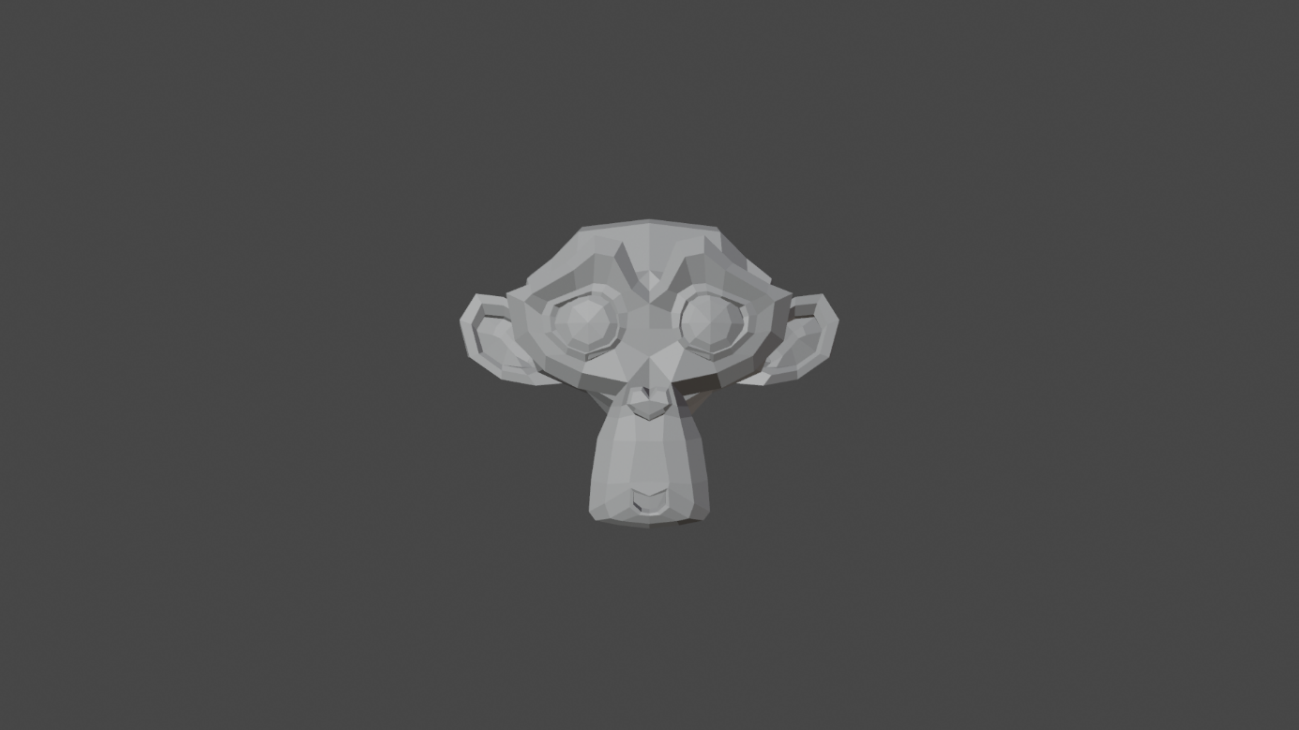

Figure 2.1 Monkey 25mm

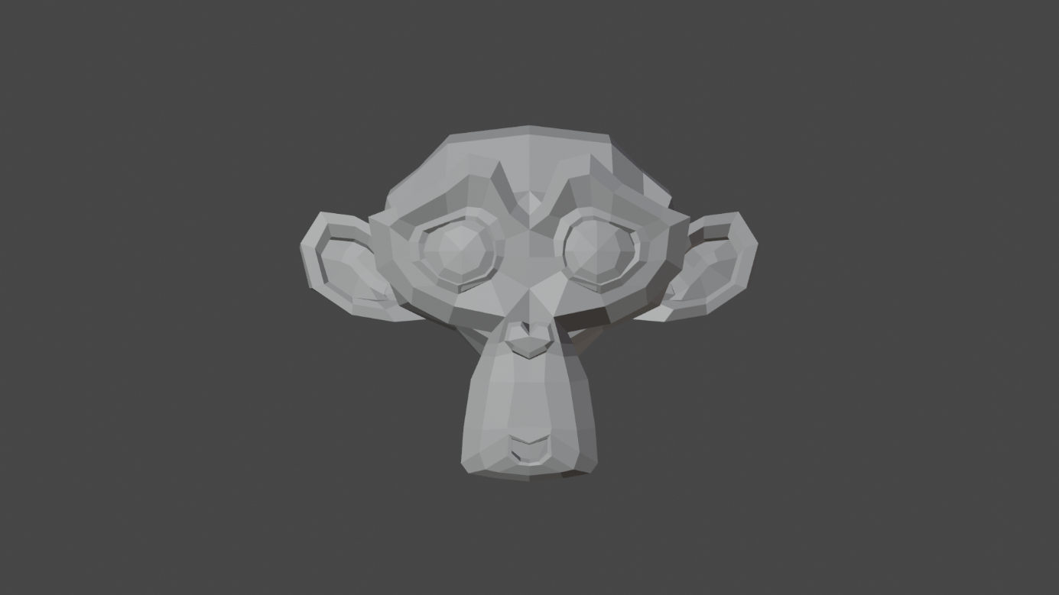

Figure 2.2 Monkey 60mm Location (0, -10,0)

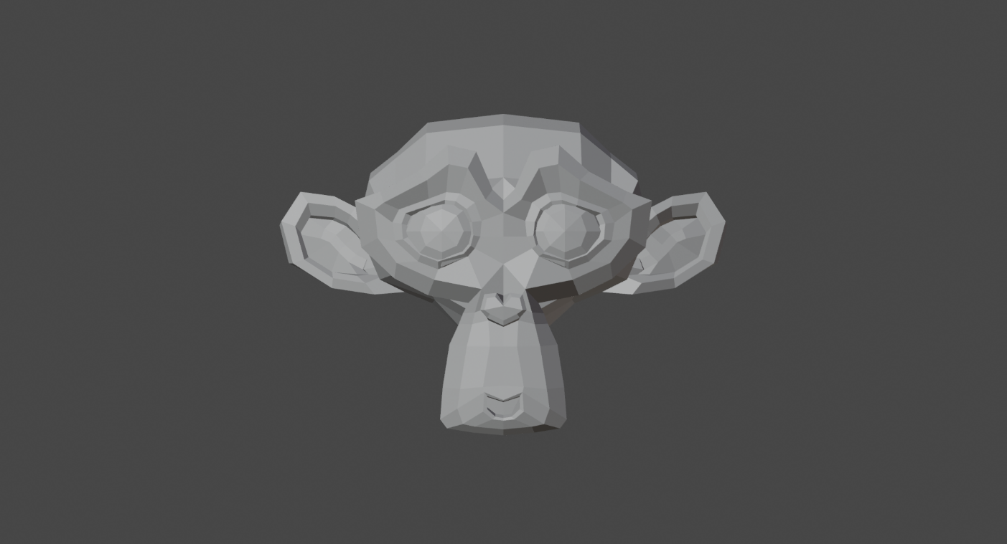

Figure 2.3 Monkey 120mm Location (0, -20,0)

**H) Compare the three images in Checkpoint 3. Discuss the effect of changing the focal length.**

Changing the focal length in 3D rendering affects the composition and perspective:

1. Focal Length: 50 mm (Default):

- Standard perspective with subject and background in balance.

2. Focal Length: 60 mm:

- Slight zoom-in, subject appears more prominent, background slightly compressed.

3. Focal Length: 120 mm:

- Significant zoom-in, subject larger in the frame, background more compressed.

The choice of focal length impacts the composition and emphasis in the scene.

**İ) Save the image with flat lighting. (Add screenshots). Write the effect of flat lighting.**



Figure 2.3 image with flat lighting.

**j) Save the rendered the image with lower light power (Add screenshots)**

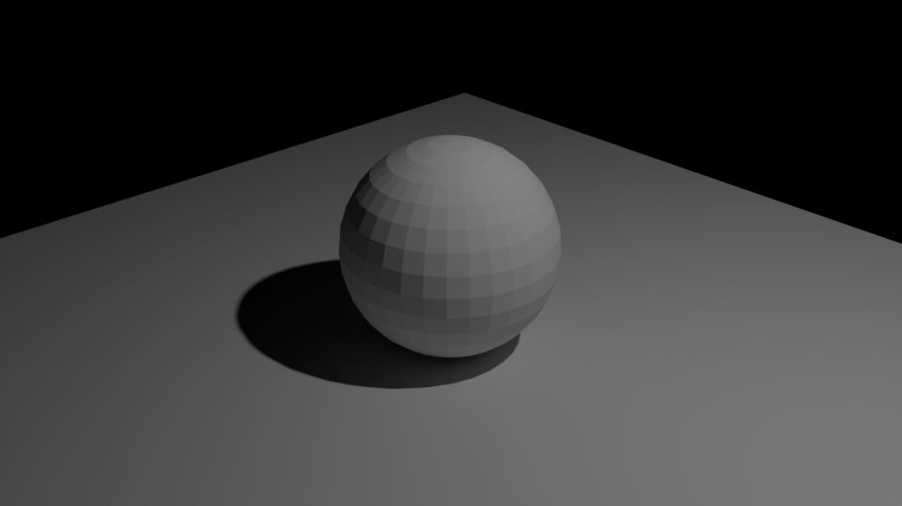

Figure 2.4 uvSphere 1920x1080 %50 low light 350w

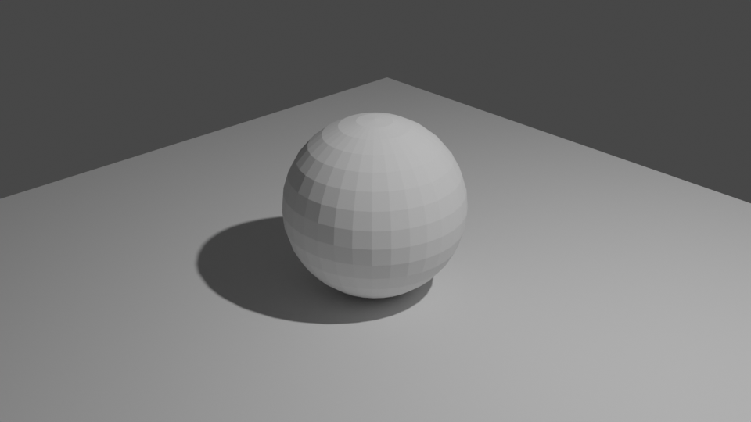

Figure 2.5 uvSphere 1920x1080 %50 1200w

**k) Compare the rendered checkpoint 8 with 8.1 State the relationship between light power and irradiance. Write your answer.**

The relationship between light power and irradiance can be summarized as follows:

Increasing the light power results in higher irradiance on the object, making the lighting brighter and more intense.

This relationship is consistent with the inverse square law, which describes how light intensity decreases with distance.

**l) Save the rendered the images with the area light. (Add screenshots)**

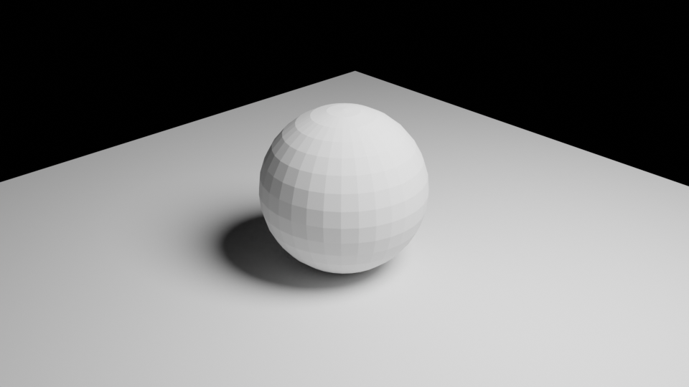

Figure 2.6 uvSphere 1920x1080 %50 area light(disk) size 4m

**top, spor ekipmanı, golf, golf topu içeren bir resim

Açıklama otomatik olarak oluşturuldu**

Figure 2.7 uvSphere 1920x1080 %50 area light(square) size 15m

**m) Save the rendered the image with the spot light. (Add screenshots)**

**top, golf, spor ekipmanı, küre içeren bir resim

Açıklama otomatik olarak oluşturuldu**

Figure 2.8 uvSphere 1920x1080 %50 spot light radius 8m 700 w

**n) Compare Checkpoint 8, Checkpoint 8.3, Checkpoint 8.4 and Checkpoint 8.5. Discuss how the shadow looks different between the point light, spot light and area light. Write your answer.**

Comparing the rendering results between the point light, spotlight, and area light configurations, we can observe the following differences in how shadows are affected:

**1. Point Light (Checkpoint 8):**

- Shadows may appear sharp and well-defined, especially when the light source is small.

- The point light creates hard-edged shadows, and the shadow transitions from light to dark are abrupt.

**2. Area Light (Disk Shape - Checkpoint 8.3):**

- Shadows tend to be softer and smoother due to the larger light source area.

- The disk-shaped area light results in diffused shadows with gradual transitions from light to dark. The shadow edges appear less defined.

**3. Area Light (Square Shape - Checkpoint 8.4):**

- Like the disk-shaped area light, square-shaped area lights create soft shadows with smooth transitions.

- The choice between disk and square shape may affect the shadow's appearance, but both provide soft shadow qualities.

**4. Spot Light (Checkpoint 8.5):**

- Spotlights create well-defined and focused shadows, with a clear distinction between the lit and shadowed areas.

- The spotlight's beam angle and focus contribute to more distinct shadows compared to area lights.

In summary, the shadow appearance varies with different types of light sources:

- Point lights produce sharp, hard-edged shadows.

- Area lights (disk or square) create softer, smoother shadows with gradual transitions.

- Spotlights generate well-defined, focused shadows with clear boundaries.

The choice of light source depends on the desired shadow characteristics and the mood or effect you want to achieve in your rendered scene. Each light type has its unique qualities that can impact the visual storytelling in a 3D rendering.